Running Surveys to Gauge Interest in A&S Classes: A Guide

Preamble
The Arts and Sciences are many and varied, and this presents a challenge to officers and stewards who want to organise classes or collegium events that appeal to the members of their group. What topics are people interested in? How advanced is their knowledge? What teachers are available?
A&S officers often decide to run a survey to find out the answers to these questions - a strategy I highly encourage! However, few officers have much prior experience running surveys, and this can make doing so a challenge.
This guide offers some advice on designing effective surveys, advertising them to your group, analysing people’s responses, and communicating your results.
I have also included an example survey with a suggested set of questions. Any officer or event steward is welcome to make a copy and adjust it to their needs.
I wish you all the best of luck in your investigation and decision-making.

Yours in Service,
Gwen verch David

Design principles for good surveys
You may look at the attached template and decide it needs some changes to fit the situation of your group - or you may decide to write your own! If you’re doing so, keep in mind the following guidelines:

Ask for the specific information you’ll use.
If you want to know whether people would attend classes on a Saturday, ask ‘would you attend classes on a Saturday?’ not ‘are you available on Saturdays?’.

Don’t ask for more information than you need.
You probably don’t need to know the age of people who answer your survey, for example. Every question you ask is more work for people to answer, and more work for you to analyse. Be brief.

Less options produce better answers.
People get tired when choosing from long lists. If you have a lot of choices for people to consider, break them up into groups of around six or less.

Multiple choice questions are easy to answer and easy to analyse.
Use them where you can, although try to include an option for ‘other’ where appropriate.

Make space for people to surprise you.
Surveys are a chance to learn something you didn’t already know. Include at least one open-ended question, like ‘Is there anything else you want to tell us?’

Use a survey tool like Google Forms or Survey Monkey to create your survey. These are easy to distribute, they collate the answers for you, and you can export the data into a spreadsheet for analysis. You can use a URL shortening tool like tiny.cc to generate a short version of the survey link.

Advertising the survey
All the design work in the world won’t make a successful survey if people don’t actually fill it out. Here are a few tips about effectively advertising one:

Make it as easy as possible to get to the survey itself.
Make the link easy to notice, easy to click and easy to copy in every announcement.

Announce who you want to hear from, what you want to know, and what the survey will be used for.
People are more likely to fill out your survey if they understand why they should do it. Telling people the survey will determine class plans will encourage them to make sure their areas of interest are on your list!

Use all the communication channels where your target audience looks for information.
If your group has a popular newsletter, use that. If there is a Facebook group for your group’s A&S activities, use that. Make announcements in meetings or by email. Whatever channel people actually use, use it!

Remind people regularly.
If I’m running a survey over a two week period, I’ll give a reminder after a week, another one three days later, and a final reminder a day before the survey closes. You don’t need to copy the full announcement in every reminder, but mention the survey’s purpose, where to find it, and the deadline.

It’s a good idea to run a complex survey for 2-4 weeks, to give people a proper chance to respond. You’ll get a sense of when a survey has reached ‘saturation’, because you’ll only get one or two new responses after your reminder instead of seeing a big bump in interest.

Interpreting the results

Decide whether you got enough answers to make a decision.
A survey is only useful if it gets answers from enough people that you can trust it to represent your group. How many people is that? It depends.
The risk of a small sample is that big surprises can hide in the group that didn’t talk to you. Small numbers also mean that statistics don’t work very well. If ten people fill out a survey, the opinion of two people makes a big difference to the numbers, but that doesn’t mean it really represents a big difference.
- If your survey gets less than 10 responses, you can use it for ideas, but take those ideas to a group meeting for a discussion, or put them out for online commentary.
- If your survey gets 10-20 responses, and your target group has less than about 150 people, that’s enough to guide planning, but be cautious about trusting any statistics to apply to the broader group.
- If your survey gets 20-50 responses, that’s a great response rate for planning something in a larger group or for a large-scale event.
As a rule of thumb, ten percent of your group is an excellent response rate!

Look for areas of agreement
In the example chart below, costuming and sewing were very popular, so they’re almost definitely worth running classes on. By comparison, very few people were interested in dyeing, so we can cross that off the list.
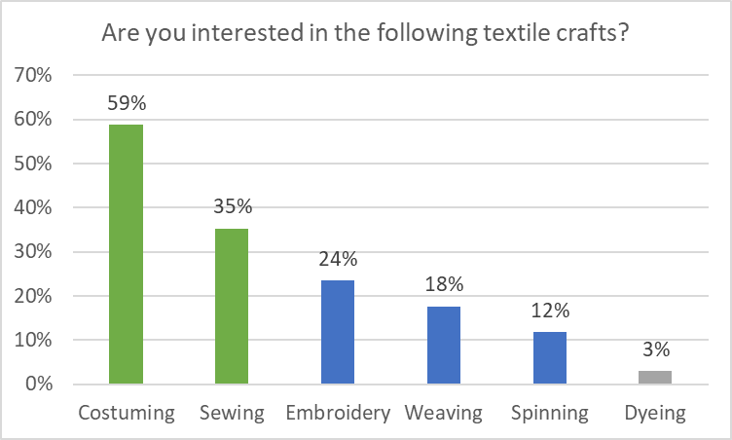
Embroidery, weaving, and spinning are in the middle. To make a decision, you’ll need to consider other factors: possible teachers; when the learners are available; whether you’re trying to promote that craft; and so on.

Compare how different groups answered the same question
Once you’ve found some groups you’re interested in (e.g. people available on Saturdays, people who don’t usually attend regular gatherings, people interested in woodwork), look at how they answered other questions compared to the rest of the population.
In the chart below, we can see that people with children interested in A&S are much more willing to attend activities on Saturdays, and much less willing to attend activities on weekday evenings. So activities aimed at families should be scheduled for weekends - not a surprising result.
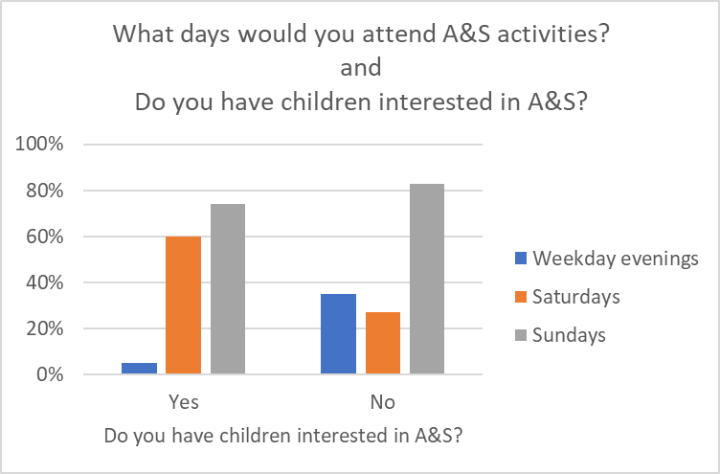

Pay attention to things that surprise you
When a survey surprises you, it means your mental picture of what’s going on wasn’t accurate. Trying to understand what’s going on will give you new information that helps you make better decisions. Often, when I’m surprised by a survey, I end up changing my plans - but I usually end up making better ones because of it.

Think about what information might be missing
There’s always details you leave out in survey design - it’s appropriate and necessary. It’s also necessary for you to remember these gaps as you think about what people told you. People’s real opinions may be more complex, or their answers may be missing fine detail. As you continue to develop your plans, it’s a good idea to make space for more complex discussions in forums like group meetings or online commentary.

Communicating the results
The most important function of a survey is to help you make a decision. The second most important function is to show your group that you are willing to listen to them, and be influenced by them. Being transparent about how the survey results have influenced your decision-making will show your group members that the survey wasn’t a waste of their time, and build support for your plans.
When discussing results, try to:

Protect people’s privacy.
Ideally, your survey isn’t asking for much private information, but sometimes people will volunteer it anyway. Make sure people who read your results can’t tell who said what.

Simplify your statistics.
Use graphs to help people compare numbers, or visualise proportions. Rather than saying how many people gave a particular answer (7 out of 65), describe it as a percentage (9%) or a ratio (1 in 10 people).

Focus on results that influenced decisions.
If you decided to run classes on the five most popular topics, share a list of the different topics and how many people were interested in each one.

Explain results that are surprising or controversial.
If the survey led you to go in a direction people might not expect, explain your reasoning process. For example “While lots of people were interested in learning pottery, no one felt comfortable teaching it. When we have our next big camping event, I’ll try to find a teacher who can visit from another group.”

Appendix: Survey Template
[Note: this template is also available as a pre-prepared Google Form, which you can save a copy of and adjust to your needs. View the form at https://bit.ly/3yf2Wjk ]

Availability
Do you attend any of our regular gatherings?
- Most of the time
- Only sometimes
- No
Would you attend a scheduled A&S class on the following days?
 | Yes | Only if it interested me | Only if there were multiple activities | No
Weekday evenings
Saturday
Sunday

Times and Places of Interest
Are you interested in any of the following periods in Europe?
 | I am interested in this period | I specialise in this period
Before 300 AD
('Ancient')
300-800 AD ('Early Middle Ages', 'Dark Ages', 'Migration Era')
800-1100 AD
1100-1300 AD ('Central Middle Ages', 'High Middle Ages')
1300-1400 AD
1400-1500 AD
1500-1600 AD

What regions outside Europe are you interested in?
 | I am interested in this region | I specialise in this region
North Africa (e.g. Moors, Islamic Empire)
Near and Middle East (e.g. Persia, Ottoman, Byzantium, Islamic Empire)
Central Asia (e.g. Mongols)
South Asia (e.g. India)
East Asia (e.g. China, Japan)
Other

If you answered ‘other’ to the previous question, what region are you interested in?

Topics of Interest
What textile crafts are you interested in?
 | I am interested in this | I can teach something about this
Costuming (for a particular period)
Sewing techniques
Embroidery
Spinning
Weaving
Dyeing
Other

What workshop crafts are you interested in?
 | I am interested in this | I can teach something about this
Leatherwork
Making wood furniture
Other woodwork
Making armour
Making jewellery
Pewter casting
Other metalwork
Pottery
Other

What kitchen and garden crafts are you interested in?
 | I am interested in this | I can teach something about this
Cooking
Brewing
Making candles
Making soaps and lotions
Herbalism
Gardening
Other

What scribal and decorative arts are you interested in?
 | I am interested in this | I can teach something about this
Calligraphy
Illumination
Printing and bookbinding
Painting
Making banners
Heraldic display
Other

What performing arts are you interested in?
 | I am interested in this | I can teach something about this
Singing
Playing an instrument
Composing
Dance
Theatre
Poetry and storytelling
Voice heraldry
Other

What theoretical topics are you interested in?
 | I am interested in this | I can teach something about this
Heraldic coats-of-arms
Name heraldry
History of particular periods or events
Period scholarship (e.g. astronomy, philosophy, natural history)
Other

What SCA skills and topics are you interested in?
 | I am interested in this | I can teach something about this
SCA camping
SCA etiquette and culture
SCA history
Running events
Feast management
Other volunteering skills
Research and documentation
Other

What are you interested in learning about or teaching that we haven't mentioned?

Children’s A&S
Do you have children who might enjoy A&S-related activities for their age group?
- Yes
- No
What age group/s are your children?
- 0-4
- 5-7
- 8-10
- 11-13
- 14 and over
Could you run an A&S-related activity for children or teenagers?
- Yes
- Maybe
- No
What age group/s would you be willing to teach?
- 0-4
- 5-7
- 8-10
- 11-13
- 14 and over

Final Thoughts
Do you have anything to add that we haven't already asked about?

Would you be interested in helping coordinate a series of classes, or helping run a collegium event?
- Yes
- Maybe
- No

If you are willing to be contacted directly by the A&S officer about teaching or coordinating, please leave your email address.

Do you have any comments on this survey?

